AREEBA NADEEM

57027

Task 1

.model small

.stack 100h

.data

.code

main proc

mov dl,'i'

mov ah,2

int 21h

mov dl,'s'

mov ah,2

int 21h

mov ah,4ch

int 21h

end main p

main end

ret

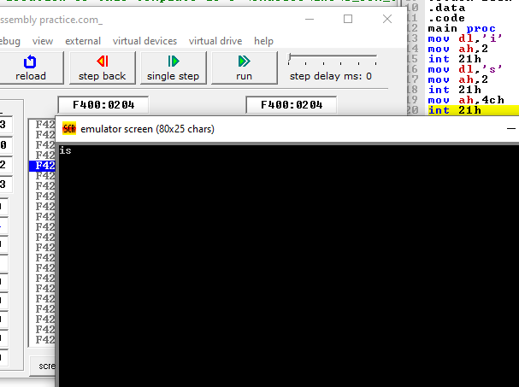

Task 2:

.model small

.stack 100h

.data

.code

main proc

mov dl,'N'

mov ah,2

int 21h

mov dl, 'a'

mov ah,2

int 21h

mov dl, 'y'

mov ah,2

int 21h

mov dl, 'a'

mov ah,2

int 21h

mov dl, 'b'

mov ah,2

int 21h

mov dl,32

mov ah,2

int 21h

mov dl, 'G'

mov ah,2

int 21h

mov dl, 'o'

mov ah,2

int 21h

mov dl,'h'

mov ah,2

int 21h

mov dl,'e'

mov ah,2

int 21h

mov dl,'r'

mov ah,2

int 21h

mov ah,4ch

int 21h

main endp

end main

ret

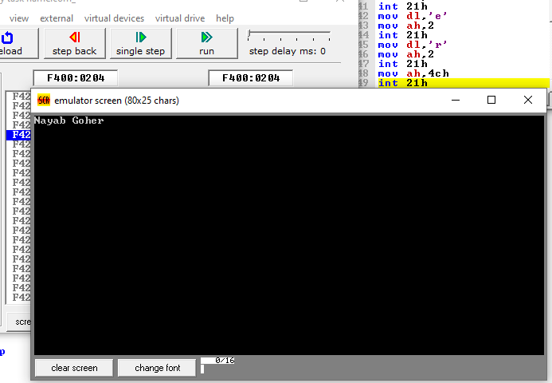

Task 3

.model small

.stack

.data

.code

main proc

mov ah,1

int 21h

mov dl,al

sub dl,32

mov ah,2

int 21h

mov ah,4ch

int 21h

main endp

end main

ret

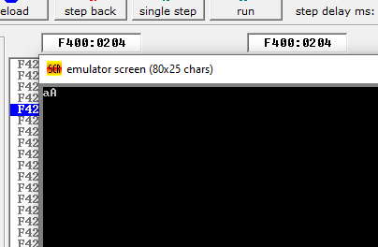

Task 4:

.model small

.stack

.code

main Proc

mov ah,1

int 21h

mov dl,al

add dl,32

mov ah,2

int 21h

main endp

end main

ret

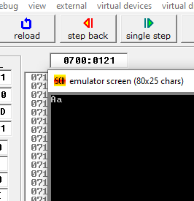

Task 5:

.model small

.stack

.data

.code

main proc

mov ah,1

int 21h

mov dl,al

mov ah,2

int 21h

ret

